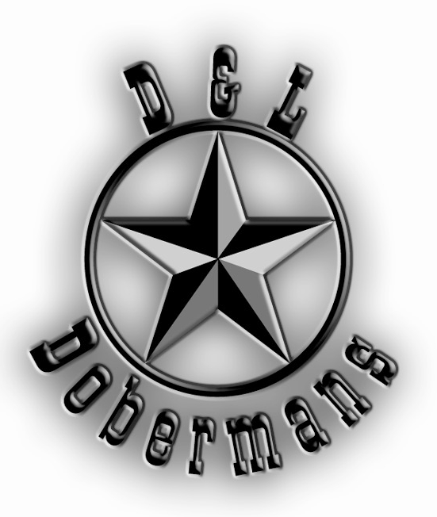

Dwight & Lesa Lewis
582 CR 759 (Terra Hills)
Jonesboro, AR 72401
(870)931-1803 home
(870)931-1802 fax
(870)974-0095 mbl
Website: www.lewisenterprises.info
Email: dandldobermans@gmail.com

Buyer Agreement
1. Buyer initials _____. Buyer agrees to provide loving, caring home and proper vet care at all times.

2. Buyer initials _____. Buyer agrees to provide adequate exercise and obedience training for puppy.

3. Buyer initials _____. Basic obedience is a MUST:
a. Crate puppy when not directly supervised.
b. Basic heeling without pulling on lead.
c. Proper socialization and interaction with others.
4. Buyer initials _____. Buyer agrees to tape and post puppy’s ears as directed by D & L Dobermans and to call with questions. If puppy’s ears do not stand then the guarantee is void. Ears crops require consistent care and attention. Neglect is inexcusable.

5. Buyer initials _____. Puppy will be released at 9 weeks of age.

6. Buyer initials _____.
Puppy price of $2,500 includes:
High quality breeding and care
Full breeder support
Full AKC registration
Custom ear crop
Microchip
Tails docked
Dewclaws removed
Vaccinations/De-worming current
Detailed puppy record (past and future)
Paper trained
Health guarantee (below).
Webcam access to watch your puppy while at D&L!

7. Buyer initials _____. Shipping is an option and is an additional $400 (including crate), if chosen by “buyer” shipping is to be prepaid in full by “buyer”.

8. Buyer initials _____. Puppy will be released to “buyer” on agreed upon date by “buyer” and D & L Dobermans. If release date is delayed by “buyer” then “buyer” may be charged additional fees to be determined by D & L Dobermans. Please plan for puppy pickup or shipment on Saturday or agreed upon date.

9. Buyer initials _____. Deposit on puppy ($500) is to be applied to puppy price and is to hold the puppy for “buyer” until adoption. Deposits are non refundable if the puppy is not adopted due to the buyer defaulting on the contract. Please make payments to Dwight or Lesa Lewis.

Puppy Information
Date of Birth: ______________
Date of Release: ___________
Sex: ____M, ____F
Color: ____Black, ____Red
Ribbon/Collar Color: ________
Puppy Name: _____________
Puppy Price ($2,500): _______
Shipping ($400 Option): ______
Pmt/Deposit: _______________
Pmt/Deposit: _______________
Balance Due: _______________

Buyer Information
Name: ____________________________________
Address: __________________________________
City, State, Zip: _____________________________
Phone: ___________________________________
Phone: ___________________________________
Email: ____________________________________
How did you find D & L Dobermans: __________________________________________

Health Guarantee

TWO YEAR HEALTH GUARANTEE
If your D & L Doberman dies from Distemper, Hepatitis, Parvo or Leptospirosis before twenty four (24) months of age, notify D & L Dobermans immediately, return the AKC registration papers along with a written veterinary statement, stating the nature of demise and necropsy verification. We will replace the dog with another puppy at no charge (buyer to prepay freight).

TWO YEAR CONGENITAL HEALTH DEFECT GUARANTEE
If your D & L Doberman develops a congenital condition that dates from the prenatal or fetus stages before twenty four (24) months of age, notify D & L Dobermans immediately and provide written veterinary verification from two (2) different veterinarians stating the defect or condition. If death occurs, necropsy verification is required. If no death occurs, you may keep the dog, but you must return the AKC papers, and a certificate of sterilization. We will replace the dog with another puppy at no charge (buyer to prepay freight).

TWO YEAR HIP GUARANTEE
The hips are guaranteed to pass and certify OFA at the age of twenty four (24) months, unless an injury or lack of proper nutrition has caused poor joint health. The puppy must continue with an excellent diet as a condition of this guarantee. If found to be crippled by hip dysplasia, notify D & L Dobermans immediately and provide written verification and x-rays from two (2) different veterinarians stating the defect and condition. You may keep the dog, but you must return the AKC papers, and a certificate of sterilization. We will replace the dog with another puppy at no charge (buyer to prepay freight).

LIMITATIONS OF ALL GUARANTEES
IF DEATH OCCURS – NECROPSY IS REQUIRED OR GUARANTEE IS VOID.
THIS HEALTH GUARANTEE COVERS ONLY THE ITEMS LISTED AND NO OTHER CONDITIONS ARE COVERED.

IF EARS ARE “CROPPED”, EARS MUST BE STANDING OR GUARANTEE IS VOID. IF EARS ARE RECROPPED, GUARANTEE IS VOID.
These guarantees apply to the original dog only and are non-transferable. Should the dog be in need of immediate veterinary treatment of a covered illness, D & L Dobermans must be notified at once, and all possible humane measures to treat the dog be attempted or no replacement will be given. Monthly heartworm prevention/intestinal de-wormer must be continued or guarantee is void. Follow-up routine vaccinations must be given at 9, 12 and 15 weeks of age and be administered by a licensed veterinarian throughout the full health guarantee period or guarantee is void. “Proof” must be available from a licensed veterinarian. Replacements may take up to one (1) year. Returned dogs must be shipped prepaid by buyer. No cash refunds, unless D&L Dobermans chooses this option. Owners are responsible for transportation costs to and from D&L Dobermans’ location for return of the original puppy and shipment of the replacement puppy as well.

Our sincere hope is that you and your dog experience a happy, long lasting bond. D & L Dobermans would also appreciate periodic updates and photos of your D & L Doberman.

Buyer’s Signature: ___________________________________

Date : ______________

D & L’s Signature : __________________________________

Date : ______________

